**Title:** *Landscape context mediates the effect of shortening fire intervals on successional trajectories in boreal systems*

*Continued short-interval fires continue to transform boreal forests beyond modeled simple conifer to deciduous transitions*

**Abstract:**

Warming temperatures in the boreal have increased the frequency and severity of wildfires, causing time intervals between fires in some areas to decrease from 50-100 years to 10-15 years within the last three decades. Shortening fire intervals have been shown to drive changes in successional pathways in boreal forests via seedbank limitation, but the extent of those changes and the role of topographic variability in promoting successional divergence remains unclear. While postfire succession in upland boreal black spruce forests is well understood, the effect of varying topography on the impact of multiple short-interval fires remains unclear. To investigate how landscape variability alters postfire successional trajectories under shortening fire intervals, we established plots across a mosaic of fire histories (1-3 fires in 70 years) in two Interior Alaska sites with differing hydrology. We compared regeneration of conifers, deciduous trees and shrubs, and graminoids across unburned controls and stands experiencing one, two or three fires in 15-year intervals in an upland site (drier) and a lowland site (wetter). All stands were originally dominated by black spruce (*Picea mariana*), and at both sites, black spruce regeneration was significantly lower following three fires, compared to unburned stands and stands burned once. In the wetter lowland site, less organic soil was consumed by fire and presence of black spruce persisted until two fires, indicating local topography may initially drive successional divergence via differences in substrate consumption. Deciduous regeneration differed between two sites after three fires, with paper birch (*Betula neoalaskana*) dominating in upland sites and willow (*Salix spp.)* and aspen (*Populus tremuloides*) in lowlands. Results of this study offer strong empirical evidence of the divergence of boreal successional trajectories from previous historic norms and indicate the importance of examining the role of spatial heterogeneity on the impact of multiple disturbances.

**I. Introduction**

Warming temperatures have been linked with global increases in the frequency and intensity of wildfires, sparking concern that changing fire regimes will lead to rapid ecosystem change if local resilience is exceeded (Young et al. 2017). Fire-free intervals in boreal systems have shrunk rapidly, and modern fire frequency in areas such as Interior Alaska is higher than any point in the last 3 thousand years (Kelly et al. 2013). Fire is the primary initiator of secondary succession in boreal systems, and as fire return intervals of < 20 years have increased across the last six decades, concerns have been raised that shortening fire intervals may disrupt or override successional trajectories entirely (Kasischke et al. 2010, Brown & Johnstone et al. 2012, Johnstone & Chapin 2006a, Johnstone & Chapin 2006b, Mann et al. 2012).

Self-replacement is the most prevalent post-fire secondary successional pathway in boreal Interior Alaska: black spruce (*Picea mariana*) typically self-replaces after fire, remaining the dominant canopy cover before and after disturbance (Kurkowski et al. 2008). This self-replacement is enabled by the semi-serotinous regeneration of black spruce: the species has high resilience to fire via a serotinous canopy seedbank, resulting in dense regeneration within 10-13 years after fire (Johnstone et al. 2004). Often referred to as a “legacy lock”, the black spruce serotinous strategy allows the species to maintain ongoing and persistent canopy coverage throughout traditional intervals of fire (Johnstone et al. 2010). However, serotinous regeneration strategies have been shown to become more vulnerable under increasing short-interval fires in boreal and other systems (Buma et al. 2013). Short interval fires can consume local serotinous seedbanks before cones reach full reproductive maturity, extirpating local populations and allowing for rapid forest type conversion (Buma et al. 2014). In the boreal specifically, empirical work shows that short fire intervals alter successional pathways through both seedbank and substrate consumption, disadvantaging local black spruce populations (Brown & Johnstone 2012, Johnstone et al. 2004, Hollingsworth et al. 2013, Johnstone & Chapin 2006a, Johnstone et al. 2009). Theoretical model outputs suggest that an increase in area reburned in short intervals may indeed disfavor serotinous regeneration to the point of forest type conversion, leading to a shift in forest community composition from conifer-dominated stands to deciduous shrublands and grasslands (Johnstone et al. 2009, Hoy et al. 2016, Roland et al. 2019, Mann et al. 2012).

Furthermore, species distribution models show climatic niche conditions satisfying physiographic requirements of both black spruce and deciduous species may expand with warming temperatures, potentially creating more opportunities for successional divergence (Kurkowski et al. 2008). The interval squeeze caused by a combination of changing demographic envelopes and shortening fire intervals may make black spruce increasingly vulnerable to local extirpation, overwhelming traditional secondary successional self-replacement pathways and allowing for the emergence of deciduous-dominated landscapes novel to the boreal (Enright et al. 2015).

Signs indicate the species-replacement post-fire successional pathway has already become more common: the transition of dominance from conifers to birch and other deciduous species following two consecutive fires has been well documented in Interior Alaska (Johnstone et al. 2004), the Yukon Territory (Brown et al. 2015, Whitman et al. 2018), Eastern Canada (Bergeron et al. 2012) and Northern Minnesota (Camill & Clark 2000, Frelich et al. 2017). This empirical work has emphasized the importance of reburning consuming serotinous seedbanks in particular, thereby limiting serotinous regeneration within the first 5-10 years postfire.

Rapid changes in fire characteristics impact successional trends beyond the direct depletion of seedbanks. Burn severity has been shown to promote deciduous dominance by consuming the deep soil organic layers common in mature black spruce boreal forests. Black spruce has larger seeds than deciduous species like aspen and birch, allowing seeds to withstand time spent in dry surface organic layers (Greene et al. 2007). The removal of soil organic layers by severe fire negates the establishment advantage of black spruce seeds providing deciduous species the competitive establishment advantage (Barrett et al. 2016, Johnstone et al. 2010X). The increasing frequency of high severity fires may further change conditions of competitive establishment in favor of deciduous species, cementing the possibility of rapid ecological change in the boreal.

[Not sure where to tie in primary succession, thinking here? Maybe lead with the idea that increasing burn severity might provide opportunities for primary succession?]

The effects of changing fire frequency and burn severity have been well documented in boreal Interior Alaska, but primarily in gently sloped upland environments typical in the Interior (Gibson et al. 2016, Houle et al. 2017). Successional trends in flatter, wetter lowland sites remain underexamined, though they represent 42% of the boreal Interior area (Douglas et al. 2014, Jorgensen and Shur 2007). Soil moisture may have important role in mediating the effects of fire on successional pathways in wetter lowland sites, providing a potential mechanism of resilience for black spruce stands (Houle et al. 2017). The under-examination of lowlands in comparison to upland sites may be in part because of the historic unlikelihood of lowlands burning. Given warming temperatures, lowland sites may begin burning more frequently, making it crucial to understand postfire successional trajectories in lowland sites, particularly if lowlands may be more resistant to the effects of shortening fire intervals.

To date, research has been limited to single reburn events (2 fires in sequence) in coniferous systems (2 fires in sequence). While this is valuable, an increase in fire frequency means repeated short interval events – and the cumulative effects of three or more fires - remains unknown, limiting our ability to make inferences regarding future boreal forest community composition. There is no information on how boreal forested ecosystems respond to such an acceleration of fire. Furthermore, research on short interval fires has almost entirely focused on conifer resilience, but the effects of short interval fires on deciduous species is unknown. Given the increasing evidence for a shift to a boreal forest dominated by deciduous species, understanding the effects of multiple fires on the emerging deciduous-dominated forest structure will be essential to understanding and predicting the impact of ongoing environmental and climatic change in high-latitude environments (Johnstone et al. 2011, Brooks et al. 2004).

This study characterizes post-fire regeneration following a rapid increase in fire frequency from the 1940s to present. We compare forest resilience across a gradient of 1-3 fires in both upland and lowland forests. We hypothesize that repeat, short interval fires will reduce conifer abundance via a reduction in the seedbank and organic layer thickness, favoring deciduous trees, as shown in other systems and studies– but that continued short interval fires will similarly disfavor traditional secondary succession communities in favor of primary succession communities. We anticipate that dry, sloped sites may be less resistant to this transition due to greater soil consumption in each fire. We test those hypotheses by A) comparing patterns of postfire regeneration across a range of fire histories within a single pre-fire forest type in upland and lowland sites and by B) linking soil organic layer characteristics to the relative abundance of plant regeneration by species. Our results provide an empirical test of the resilience of black spruce forest communities in uplands and lowlands to shortening fire intervals, and also the effects of shortening fire intervals on emergent deciduous-dominated boreal upland and lowlands.

**II. Methods**

**Site Selection**

We established 50 individual 20x20m plots across two locations in Interior Alaska in natural mosaics of stands differing in recent fire history. Each plot experienced between one to three fires in the last 60 years, with the final burn in XXX-XXX. Eight unburned plots were established as controls (total n=50).

Site History: All plots were dominated by black spruce (*Picea mariana*) before the first fire with occasional birch (*Betula neoalaskana*) or trembling aspen (*Populus tremuloides*). Presence of spruce prior to the burn sequence was established from modern remotely sensed landscape cover data where and when available (Supplement 1), and ground-truthed by opportunistically sampling downed woody debris of black spruce of various ages. Fire severity has a well-documented role in post-fire forest community composition in the boreal (Hollingsworth et al. 2013). To control for fire severity, all plots experienced full canopy mortality during each fire, as identified by aerial photography and remotely sensed fire perimeters.

Individual plots were established across a range of slopes and aspects (Fig. X). Upland plots receive an average of XX inches of rainfall per year, while lowland plots receive XX. Size of plots, slope and aspect taken from XX source.

Burn history was established based on both historic aerial photographs from XXX source, and modern remotely sensed fire perimeters from XX source. The fire history mosaic at both sites allowed us to adventitiously sample forests with different reburn rates while constraining for time since fire. We sampled sites representing four specific stages of reburn history: 1) mature unburned black spruce forest stands, 2) once-burned black spruce forest recovering from a single short-interval fire (~15 years ago), 3) twice-burned black spruce forest recovering from two short-interval fires (one ~ 30 years ago, and the second ~15 years ago), and 4) thrice-burned black spruce forest, burned once ~45 years ago, a second time ~30 years ago and finally a third ~15 years ago (Figure X – photos of plots). Time between fires was constrained to 10-15 years, and all plots last burned 15 to 16 years ago. Boreal successional pathways are considered locked in place within two years after fires, meaning the 15-year postfire regeneration trends at our plots represent the direction of longer-term successional trajectories (Ott et al. 2006, Johnstone et al. 2004).

Site Locations: Plots were randomly placed within the various burn histories, with a minimum of 50 meters spacing and a minimum of 50 meters away from unburned legacies. Plots were stratified evenly between an upland site and a lowland site. The upland site represents well drained boreal forest; the lowland a flatter, more poorly drained location. Both are on the northern edge of the discontinuous permafrost zone; with nearby unburned black spruce communities have shallow permafrost in both locations (data not shown).

[Soil paragraph]

**Field Sampling**

Stems above diameter breast height (DBH) and seedlings were counted in each plot; where density precluded counting over the entire 400m2, a randomly selected subset (100 or 200 m2) was counted. Canopy health, presence of browse, and understory species were noted for each stem counted above DBH. For asexual reproducers such as willow and aspen, each individual stem in a given clump was counted and then clumps were pooled and treated as individuals. Distance from adventitious roots to soil surface was measured where snags were available to sample. Organic layer depth was measured at the center and at each corner of each plot. Presence and abundance of soil cover was estimated across 1-meter subplots at each corner of each site.

**Data Analysis**

We used linear mixed effect (LME) models to investigate the effect of substrate consumption on regeneration abundance of each species. Each model included an interaction between the fixed effects of fire history and site. The best structure for each model was selected based on the lowest AIC value and F-test comparisons (Table #).

All analyses were performed in R version 1.2.1335 (R Development Core Team, 2014) and reported means include +/- 1 standard deviation. Welch two sample t-tests were run in R to compare specific differences in regeneration across fire histories. Generalized mixed-models were conducted through ‘lme4’ (Bates et al. 2019). Figures were created through ‘ggplot2’ (Wickham 2016) and ‘cowplot’ (Wilkes et al. 2019). All dependent variables were log-transformed to meet assumptions of normality. Because our plots are clustered by design to take advantage of natural experimental conditions, spatial autocorrelation among plots was assessed by [EXPLAIN]. We found no evidence of spatial autocorrelation (Table #) but accounted for the grouping of plots in sites by including site as a random effect in LMEs.

**III. Results**

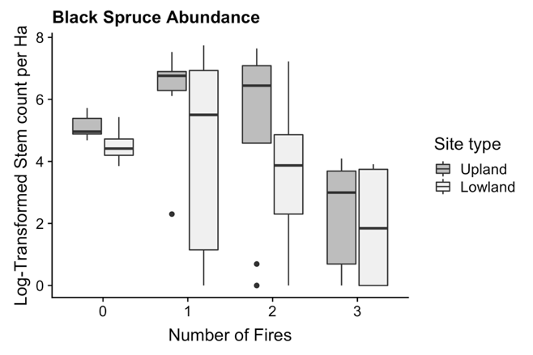

**Figure X. Density of black spruce seedlings and established trees according to number of fires.**

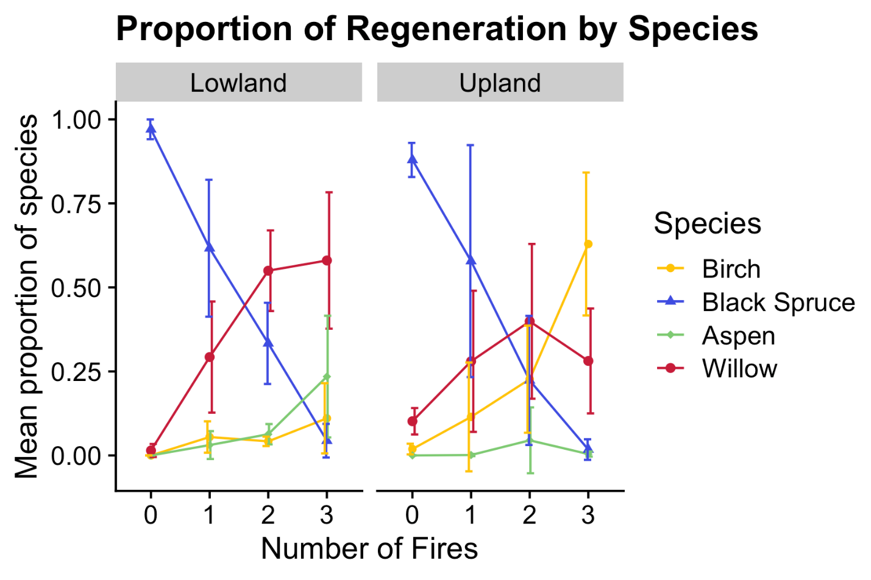

**Figure X. Average proportion of species present at each burn history between upland and lowland sites. Error bars represent standard deviations**

**Seedling regeneration**

Black spruce seedlings are most abundant in unburned plots in both uplands (86.7%, standard deviation 11.4%) and lowlands (98.2%, standard deviation 3.5%), but presence declines with increasing fires to 2.2% (standard deviation 3.2%) and 4.9% (standard deviation 5.5%) in thrice-burned upland and lowland plots respectively. Deciduous seedling presence increases across fire history in both upland and lowland plots: upland plots saw increases in birch and willow seedlings between one, two and three fires, while lowland plots were characterized by increasing presence in willow seedlings alongside a significant increase in aspen seedlings between twice and thrice burned plots (p-value).

**Overstory regeneration**

Individuals above DBH represent the first cohort of trees to establish after the most recent fire. Unburned plots in both sites are heavily populated with black spruce (upland plots 89.7% +/ 5.6%, lowland plots 95.5% +/- 7.3%) and occasional birch (upland 0.02% +/- 2.19%, lowland 0%) and willow (upland plots X%+/-) as expected. Once-burned plots in both upland and lowland sites are populated by …

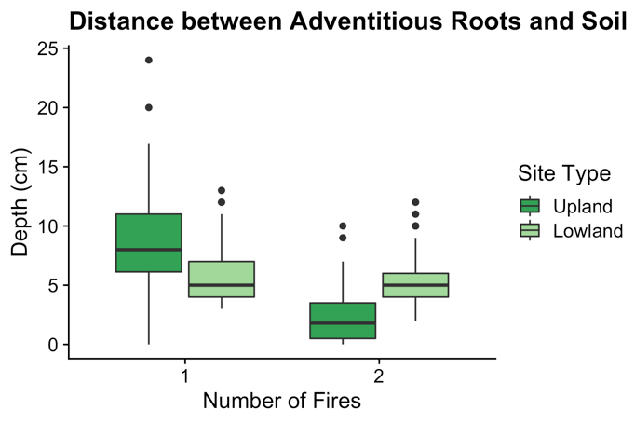

**Figure X. Distance in centimeters between highest adventitious black spruce roots to soil surface across fire history.**

**Adventitious roots**

Adventitious roots were only available to sample in once- and twice-burned plots. Depth from adventitious root to current soil surface ranged from 0 to 24 cm in once-burned upland plots, and 3 to 7 cm in once-burned lowland plots. Average adventitious root depth in upland plots shrank between once- and twice-burned plots by a factor of 2.4. Adventitious root depth in lowland plots did not differ significantly (p-value = 0.1064) between once-burned and twice-burned plots.

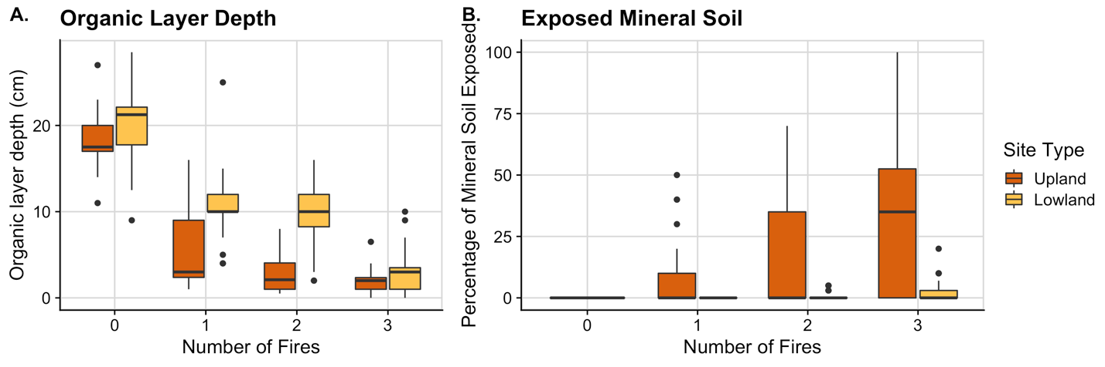

**Figure X. A) Depth of Organic Layer (cm) between Upland and Lowland Sites according to burn history. B) Percent cover of exposed mineral soil in Upland and Lowland sites across burn history.**

**Soil Consumption**

Lowland organic-layers were thicker than upland layers regardless of burn history by a factor of 1.6, and the difference between the two sites was largest in twice-burned plots where lowland organic-layers were larger by a factor of 3.2. The decline in organic layer depth occurs faster in upland plots than in lowland plots: organic layers were reduced by a factor of X after one fire in upland plots, but only by a factor of X in lowland plots. Organic layer depths do not become statistically similar between the two sites until three fires (p-value). Similar trends exist for exposed mineral soil: upland plots had no exposed mineral soil in unburned sites, but saw an increased in the amount of exposed mineral soil, up to 100% in some thrice-burned plots.

**Model Results**

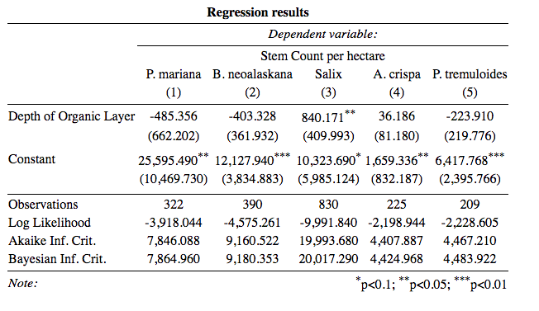

Results from the linear mixed model indicate a significant association between organic layer depth and black spruce regeneration after controlling for the variation found between number of fires and site (p-value = < 2e-16).

**IV. Discussion**

**Seedling Regeneration**

This study shows a decline in black spruce across short-interval reburns much stronger than those found in single postfire successional studies, or even single reburn successional studies: Johnstone et. al 2004 found black spruce to be 98% of all postfire tree seedlings after a single fire, with stem densities between 1-9 stems per square meter [Double check if stems or seedlings]. Our seedling densities in once-burned plots are similar, but soon plummet to densities <1 seedling per square meter in thrice-burned plots, with stem densities of zero occurring by the same number of fires. This sharp decline in abundance of both black spruce seedlings and established trees is clear empirical evidence of that the short-interval fires in our study reduce serotinous seedbanks, and therefore subsequent population establishment.

**Overstory Regeneration paragraph**

**Soil Consumption**

The divergence in organic layer consumption indicates a difference in fire effects between the upland and lowland sites: less organic layer is consumed in lowland sites after one and two fires, indicating that wetter conditions may mediate the effect of even high-severity fires. Furthermore, upland sites had significantly more mineral soil exposed in burned sites, even with substantial within-treatment variation. Given the role of burn severity in altering circumstances of competitive standing between coniferous and deciduous species, this variation between sites indicates that heterogeneity in hydrology via local topography may facilitate resilience or resistance in black spruce stands experiencing increasing short interval fires. Local soil moisture may act as a mechanism of resistance to short fire intervals only up until a given threshold of fire exposure, given that the organic layers in thrice-burned lowland sites did become statistically similar to those found in thrice-burned upland plots.

Our regeneration results indicate a boreal forest successional trajectory untethered from regional legacy conditions. The abundance of black spruce in burned plots is low enough to suggest the prevention of self-replacement as a future successional pathway in those specific sites. Furthermore, deciduous species are emerging in assemblages novel to Interior Alaska boreal forests: the strong presence of willow and aspen in particular indicate the emergence of not only a species-replacement successional trajectory, but a species-replacement successional trajectory much more in line with primary successional trends than secondary.

Within the broader context of fires in the boreal, these results indicate that multiple short-interval fires may reduce serotinous conifer populations, allowing for the emergence of woodlands or shrublands dominated by deciduous species. Furthermore, emerging deciduous communities appear to …Wetter lowland forests may be initially more resistant to this transition, given the mitigating effects of soil moisture, but that resilience may be overcome by subsequent fires. This study demonstrates the site-level impacts of 3 repeat short interval fires, but the impact of increasing fire frequency on the landscape-level remains to be seen.

**References**

Bates, Douglas M. "lme4: Mixed-effects modeling with R." (2010): 470-474.

Barrett, K., et al. "Potential shifts in dominant forest cover in interior Alaska driven by variations in fire severity." *Ecological applications* 21.7 (2011): 2380-2396.

Bergeron, Yves, and Nicole J. Fenton. "Boreal forests of eastern Canada revisited: old growth, nonfire disturbances, forest succession, and biodiversity." *Botany* 90.6 (2012): 509-523.

Brooks, Matthew L., et al. "Effects of invasive alien plants on fire regimes." *BioScience* 54.7 (2004): 677-688.

Brown, Carissa D., et al. "Disentangling legacy effects from environmental filters of postfire assembly of boreal tree assemblages." *Ecology* 96.11 (2015): 3023-3032.

Brown, Carissa D., and Jill F. Johnstone. "Once burned, twice shy: Repeat fires reduce seed availability and alter substrate constraints on Picea mariana regeneration." *Forest Ecology and Management* 266 (2012): 34-41.

Buma, Brian, et al. "The impacts of changing disturbance regimes on serotinous plant populations and communities." *BioScience* 63.11 (2013): 866-876.

Camill, Philip, and James S. Clark. "Long-term perspectives on lagged ecosystem responses to climate change: permafrost in boreal peatlands and the grassland/woodland boundary." *Ecosystems* 3.6 (2000): 534-544.

Douglas, Thomas, et al. "Sources and sinks of carbon in boreal ecosystems of interior Alaska: A review." *Elem Sci Anth* 2 (2014).

Enright, Neal J., et al. "Interval squeeze: altered fire regimes and demographic responses interact to threaten woody species persistence as climate changes." *Frontiers in Ecology and the Environment* 13.5 (2015): 265-272.

Frelich, Lee E., Peter B. Reich, and David W. Peterson. "The changing role of fire in mediating the relationships among oaks, grasslands, mesic temperate forests, and boreal forests in the Lake States." *Journal of Sustainable Forestry* 36.5 (2017): 421-432.

Gibson, Carolyn M., et al. "Variation in plant community composition and vegetation carbon pools a decade following a severe fire season in interior Alaska." *Journal of vegetation science* 27.6 (2016): 1187-1197.

Greene, David F., et al. "The reduction of organic-layer depth by wildfire in the North American boreal forest and its effect on tree recruitment by seed." *Canadian Journal of Forest Research* 37.6 (2007): 1012-1023.

Hollingsworth, Teresa N., et al. "Fire severity filters regeneration traits to shape community assembly in Alaska’s boreal forest." *PloS one* 8.2 (2013): e56033.

Houle, Gregory P., et al. "Recovery of carbon pools a decade after wildfire in black spruce forests of interior Alaska: effects of soil texture and landscape position." *Canadian Journal of Forest Research* 48.1 (2017): 1-10.

Hoy, Elizabeth E., Merritt R. Turetsky, and Eric S. Kasischke. "More frequent burning increases vulnerability of Alaskan boreal black spruce forests." Environmental Research Letters 11.9 (2016): 095001.

Johnstone, Jill F., and F. Stuart Chapin. "Effects of soil burn severity on post-fire tree recruitment in boreal forest." *Ecosystems* 9.1 (2006): 14-31. A

Johnstone, J. F., and F. S. Chapin. "Fire interval effects on successional trajectory in boreal forests of northwest Canada." *Ecosystems* 9.2 (2006): 268-277. B

Johnstone, Jill F., et al. "Decadal observations of tree regeneration following fire in boreal forests." *Canadian Journal of Forest Research* 34.2 (2004): 267-273.

Johnstone, Jill F., et al. "Changes in fire regime break the legacy lock on successional trajectories in Alaskan boreal forest." *Global Change Biology* 16.4 (2010): 1281-1295.

Johnstone, Jill, et al. "Postfire seed rain of black spruce, a semiserotinous conifer, in forests of interior Alaska." *Canadian Journal of Forest Research* 39.8 (2009): 1575-1588.

Johnstone, Jill, et al. “Modeling impacts of fire severity on successional trajectories and future fire behavior in Alaskan boreal forests.” *Landscape Ecology*, 26.4 (2011).

Jorgenson, M. Torre, and Yuri Shur. "Evolution of lakes and basins in northern Alaska and discussion of the thaw lake cycle." *Journal of Geophysical Research: Earth Surface* 112.F2 (2007).

Kasischke, Eric S., and Merritt R. Turetsky. "Recent changes in the fire regime across the North American boreal region—Spatial and temporal patterns of burning across Canada and Alaska." Geophysical research letters 33.9 (2006).

Kasischke, Eric S., et al. "Alaska’s changing fire regime—implications for the vulnerability of its boreal forests." *Canadian Journal of Forest Research* 40.7 (2010): 1313-1324.

Kelly, Ryan, et al. "Recent burning of boreal forests exceeds fire regime limits of the past 10,000 years." Proceedings of the National Academy of Sciences 110.32 (2013): 13055-13060.

Kurkowski, Thomas A., et al. "Relative importance of different secondary successional pathways in an Alaskan boreal forest." Canadian Journal of Forest Research 38.7 (2008): 1911-1923.

Mann, Daniel H., et al. "Is Alaska’s boreal forest now crossing a major ecological threshold?." *Arctic, Antarctic, and Alpine Research* 44.3 (2012): 319-331.

Ott, L. A. V. R. A., P. C. A. D. Mann, and Keith Van Cleve. "Successional processes in the Alaskan boreal forest." *Alaska’s changing boreal forest* (2006): 100.

Roland, Carl A., et al. "Regional variation in interior Alaskan boreal forests is driven by fire disturbance, topography, and climate." *Ecological Monographs* (2019): e01369.

Whitman, Ellen, et al. "Topoedaphic and forest controls on post-fire vegetation assemblies are modified by fire history and burn severity in the Northwestern Canadian Boreal Forest." *Forests* 9.3 (2018): 151.

Wickham, H. "Ggplot2: Elegant graphics for data analysis. (Springer-Verlag: New York)." (2016).

Wilke, C. “cowplot: Streamlined Plot Theme and Plot Annotations for ‘ggplot2;” R package version 0.9.4 (2019). https://CRAN.R-project.org/package=cowplot

Young, Adam M., et al. "Climatic thresholds shape northern high‐latitude fire regimes and imply vulnerability to future climate change." Ecography 40.5 (2017): 606-617.

**[Table of fires, dates, sizes (might do as sites, with the associated fire at each site)]**

|  |  |  |  |  |  |  |
| --- | --- | --- | --- | --- | --- | --- |
| Setting | Treatment | Species | Seedling Density | Seedling SD | Stem Density | Stem SD |
| Lowland | 0 | Aspen | 0 | 0 | 0 | 0 |
|  |  | Birch | 0 | 0 | 0 | 0 |
|  |  | Black spruce | 1.6225 | 0.605 | 0.97 | 0.42559762 |
|  |  | Willow | 0.0275 | 0.055 | 0.0075 | 0.005 |
|  | 1 | Aspen | 0.471428571 | 0.670110154 | 0.00166667 | 0.00408248 |
|  |  | Birch | 0.742857143 | 0.752456295 | 0.09166667 | 0.09780934 |
|  |  | Black spruce | 9.571428571 | 4.623748222 | 0.00833333 | 0.02041241 |
|  |  | Willow | 5.342857143 | 3.859990131 | 0.025 | 0.01843909 |
|  | 2 | Aspen | 2.033333333 | 1.540995349 | 0.01 | 0.00774597 |
|  |  | Birch | 0.966666667 | 0.27325202 | 0.07916667 | 0.05774224 |
|  |  | Black spruce | 10.36666667 | 6.321286789 | 0.0025 | 0.0041833 |
|  |  | Willow | 15.43333333 | 5.153122031 | 0.12 | 0.24091492 |
|  | 3 | Aspen | 1.9 | 1.089342309 | 0.266875 | 0.19484311 |
|  |  | Birch | 0.728571429 | 0.540722621 | 0.04 | 0.03664502 |
|  |  | Black spruce | 0.342857143 | 0.161834719 | 0.00375 | 0.00443203 |
|  |  | Willow | 7.985714286 | 7.635318935 | 0.246875 | 0.16881811 |
| Upland | 0 | Aspen | 0 | 0 | 0 | 0 |
|  |  | Birch | 0.0075 | 0.015 | 0.015 | 0.00912871 |
|  |  | Black spruce | 0.675 | 0.19485037 | 0.6575 | 0.33819373 |
|  |  | Willow | 0.11 | 0.111654228 | 0.05125 | 0.03727712 |
|  | 1 | Aspen | 0.028571429 | 0.075592895 | 5.00E-04 | 0.00158114 |
|  |  | Birch | 4.164285714 | 6.644842253 | 0.208 | 0.32975749 |
|  |  | Black spruce | 10.45 | 8.421698166 | 0.0065 | 0.01546501 |
|  |  | Willow | 8.957142857 | 10.43118037 | 0.1 | 0.13274872 |
|  | 2 | Aspen | 0.065 | 0.11351526 | 0.010625 | 0.01781602 |
|  |  | Birch | 0.91875 | 1.469095324 | 0.300625 | 0.28895671 |
|  |  | Black spruce | 2.45 | 4.66268776 | 0.000625 | 0.00176777 |
|  |  | Willow | 4.7575 | 5.487551497 | 0.123125 | 0.17854446 |
|  | 3 | Aspen | 0.003333333 | 0.008164966 | 0.00166667 | 0.00408248 |
|  |  | Birch | 5.065 | 9.584898017 | 0.49583333 | 0.64749839 |
|  |  | Black spruce | 0.153333333 | 0.232005747 | 0 | 0 |
|  |  | Willow | 0.7 | 0.670134315 | 0.10166667 | 0.06524314 |